

**TRIBHUVAN UNIVERSITY**

**INSTITUTE OF ENGINEERING**

**PASCHIMANCHAL CAMPUS**

**A PROJECT FINAL REPORT ON**

**Performace Analysis on Placement and Sizing of D-STATCOM in Radial Distribution Network:**

**A case Study in Begnas Feeder,Lekhnath**

**Submitted By:**

**Shankar Singh Thakuri (079/MSDGE/016)**

**A FINAL PROJECT REPORT**

**SUBMITTED TO DEPARTMENT OF ELECTRICAL ENGINEERING**

**IN PARTIAL FULFILLMENT OF THE REQUIREMENT FOR THE**

**DEGREE OF MASTER OF SCIENCE IN ELECTRICAL ENGINEERING**

**IN DISTRIBUTION GENERATION**

**DEPARTMENT OF ELECTRICAL ENGINEERING**

**PASCHIMANCHAL CAMPUS**

**LAMACHOUR, POKHARA**

**SEPTEMBER,2024**

**Performace Analysis on Placement and Sizing of D-STATCOM in Radial Distribution Network:**

**A case Study in Begnas Feeder,Lekhnath**

By

Shankar Singh Thakuri

Asst. Prof. Sandeep Dhami

Supervisior

M.S.C Program Program Cordinator

Department of Electrical Enginneering

Tribhuwan University

**ACKNOWLEDGEMENT**

I would like to express my sincere gratitude to my project supervisor, Assistant Professor Sandeep Dhami, the MSc Coordinator for his wise counsel, motivation, and inspiration throughout this study. Thank you so much for your encouragement, advice, and insights on this endeavor.

In addition, I would like to thank the Electrical Engineering Department professors at Pashchimanchal Campus for their thoughtful advice and comments throughout the project's many stages.

I would like to express my gratitude to Lekhnath DCS and Pokhara Grid Substation, NEA, for their assistance in supplying the data and clarification needed for the system's modeling, as well as for their advice during the project's implementation.

I would also like to thank my colleagues for their unwavering support during the investigation. Allow me to express my gratitude to the publishers and authors of all the materials that were helpful throughout this entire learning process.

**ABSTRACT**

An electric power system's distribution system connects high-voltage transmission networks to final users. This work provides a method for enhancing the voltage profile and lowering power loss in the distribution network by introducing reactive power into the system. Power quality problems such as low voltage and higher loss are typically found in radial distribution networks or systems with long line lengths and heavy loading. The Lekhnath Distribution Center's Begnas Feeder is the subject of this investigation. In this work, the first condition has aimed to find the best optimal D-STATCOM sizing and placement by using Variational Technique method.Backward and forward load flow analysis is Selected to compute all the required parameters in the existing Distribution System D-STATCOM is used to improve bus voltage profile By the placement and sizing of D-STATCOM the voltage profile improved and the power loss reductions are obtained in the 11 KV Begnas Feeder of Lekhnath DC. The results obtained are compared without and with D-STATCOM.

**TABLE OF CONTENTS**

LIST OF FIGURES I

LIST OF TABLE 1

LIST OF ABBREVIATION 2

CHAPTER ONE: INTRODUCTION 3

1.1 BACKGROUND 3

1.2 PROBLEM STATEMENT 3

1.3 RATIONALE OF PROJECT 4

1.4 OBJECTIVES 4

1.5 LIMITATIONS 4

CHAPTER TWO: LITERATURE REVIEW 5

2.1 Overview of Distribution Network: 6

2.2 D-STATCOM Allocation Technique for Loss Reduction 6

2.3 Power flow/Load Flow: 7

2.3.1 Calculation of load current 7

2.3.2 Backward Forward Sweep Method: 8

CHAPTER THREE: METHODOLOGY 9

3.1 Collection of Data: 9

3.2 Optimal Location of D-STATCOM 10

3.2.1 Voltage Stability Index for finding optimal location of D-STATCOM 10

3.2.2 Optimal size calculation by variational technique 10

1.3 Flow Chart of Proposed Methodology 11

CHAPTER FOUR: RESULT AND DISCUSSION 12

4.1 Load Flow Analysis of 33 Test Bus System 12

4.2 Load flow Analysis of Begnas Feeder 15

4.3 Voltage Stability Index Calculation 19

4.4 Comparison of D-STATCOM size calculation by Variational Technique 20

CHAPTER FIVE: CONCLUSION AND RECOMMENDATION 21

REFERENCES 22

APPENDIX 23

# LIST OF FIGURES

Figure 1:Radial Distribution Network 6

Figure 2:Phasor Graph of D-STATCOM 7

Figure 3: Flowchart of proposed System

Figure 4:Active Power Loss in 33 Test Bus System Figure 5: Reactive Power Loss in 33 Test Bus System 13

Figure 6:Voltage Profile of 33 Test Bus 14

Figure 7: Active Power Loss in Begnas Feeder 17

Figure 8: Reactive Power Loss of Begnas Feeder 17

Figure 9 : Voltage Profile of Begnas Feedder 18

## **LIST OF TABLE**

Table 1 : Voltage Profile and Power loss in 33 Test Bus System 12

Table 2 :Voltage Profile and Power loss in Begnas Feeder 15

Table 3: VSI of Begnas Feeder 19

Table 4 : Variational Technique for finding the optimum size of D-STATCOM 20

Table 5 : Specification of ACSR Conductor 23

Table 6 : Line Data of 33 Test Bus System 24

Table 7 : Load Data of 33 Test Bus System 25

Table 8 : Line Data of Begnas Feeder 26

Table 9 : Load Data of Begnas Feeder 28

## **LIST OF ABBREVIATION**

ABC AERIAL BUNDLED CONDUCTOR

AC ALTERNATING CURRENT

ACSR ALUMINUM CONDUCTOR REINFORCED

DC DIRECT CURRENT

DCS DISTRIBUTED CONTROL SYSTEM

DG DISTRIBUTED GENERATION

INPS INTEGRATED NEPAL POWER SYSTEM

HT HIGH TENSILE

NEA NEPAL ELECTRICITY AUTHORITY

VSI VOLTAGE STABILITY INDEX

# CHAPTER ONE: INTRODUCTION

## **BACKGROUND**

To enhance voltage profiles, lower losses, and conserve energy, distribution systems integrating distributed generation (DG), custom power devices (CPDs), and capacitors must conduct an optimal load flow assessment. Reactive power management, loss reduction, distribution system pricing, and reserve management during peak loads are among the challenges that are addressed by the proper placement of these components. Reactive power demands rise in distribution systems because most loads are reactive. This reactive power can be provided by capacitors, but they may oscillate and their output is dependent on the system voltage. Originally designed for transmission systems, FACTS devices are now utilized in distribution to compensate for reactive power, taking on the role of capacitors or inductors as required.

CPDs that regulate voltage, phase angle, and line impedance effectively and dependably include DVR, D-STATCOM, and UPQC. D-STATCOM is a particularly useful one among them, providing better bus voltage profiles and continuously changing reactive power compensation. A transformer, PWM control technique, inverter modules, ac filter, and dc capacitor are among its primary parts. In both steady-state and dynamic scenarios, D-STATCOM improves voltage control, balancing, and power losses. The effectiveness of D-STATCOM in enhancing voltage profiles and lowering losses in distribution networks has been demonstrated by a number of studies that have suggested methods for appropriate D-STATCOM placement and sizing.

With size estimations made using a variational strategy, this article analyzes D-STATCOM allocation strategies for radial distribution networks using the voltage stability index (VSI) approaches. This technique enhances voltage profiles while reducing line losses. The load flow method consists of three basic steps: figuring out the load current, creating the BIBC matrix, and sweeping the line forward. The bus with the greatest VSI and PLI values is chosen as the candidate bus after a load flow study is performed. We then apply the variational technique to determine the D-STATCOM size. Lastly, using MATLAB, the load flow is re-evaluated at the candidate bus for IEEE 33-bus test systems with the D-STATCOM.

## **PROBLEM STATEMENT**

The electrical power distribution system is an essential part of the infrastructure that ensures the efficient and reliable transport of electricity from generation sources to end consumers. However, maintaining the optimal voltage profile and minimizing losses in the distribution network remain formidable obstacles. These issues could lead to excessive power consumption, increased operational costs, and a deterioration in the reliability and quality of the services.

Research paper's problem statement focuses on solving problems with reactive power management, improving voltage profiles, and lowering power losses in radial distribution systems. It draws attention to the drawbacks of employing capacitors for reactive power adjustment, including their propensity to cause oscillations and reliance on system voltage. As a substitute, the study suggests using D-STATCOM, a static compensator based on a shunt-connected voltage source converter. In order to improve the effectiveness and efficiency of radial distribution networks, the study intends to identify the ideal placement and size of D-STATCOM utilizing voltage stability index (VSI), followed by size calculation through a variational technique.

​

## **Objectives**

The objectives of the project are:

* To compare the effectiveness of Voltage Stability Index (VSI) approach for the optimal allocation of D-STATCOM in a radial distribution network.
* To determine the corresponding sizes of D-STATCOM using a variational technique.
* To demonstrate the reduction of line losses and improvement in the voltage profile of the distribution network through the optimal placement and sizing of D-STATCOM.
* To conduct load flow analysis on a radial distribution system to identify candidate buses for D-STATCOM placement.

## **OBJECTIVES**

## **Report Organisation**

# CHAPTER TWO: LITERATURE REVIEW

The increasing use of capacitors, custom power devices, and distributed generation in distribution systems necessitates a thorough load flow study to determine their optimal placement for improved voltage profile management, loss reduction, and overall energy savings. Reactive power compensation is crucial due to the prevalence of reactive loads like motors and pumps [9]. While capacitors are traditionally used for this purpose, their dependency on system voltage and potential for oscillations pose challenges. FACTS devices, including D-STATCOM, offer a more flexible solution by dynamically adjusting reactive power compensation based on system needs. D-STATCOM, a shunt-connected device, excels in voltage profile improvement and loss reduction. Its advantages include low harmonic distortion, compact size, and continuous operation. This paper focuses on comparing D-STATCOM allocation methods using voltage stability and power loss indices, along with size calculation using a variational technique, to enhance distribution system performance.

Flexible AC Transmission System (FACTS) devices, such as DSTATCOM and UPQC, are increasingly used to address issues in power systems, including low voltage distribution, power quality improvement, and reliability for sensitive loads. These devices offer solutions for reactive power compensation and unbalanced loading under various system conditions. Optimal placement of these devices is crucial for their effectiveness. DSTATCOM, a shunt-connected device, is favored for its advantages like low harmonic distortion, compact size, and continuous operation. Previous research has explored various optimization algorithms for DSTATCOM placement, including immune algorithms, Particle Swarm Optimization (PSO), hybrid heuristic techniques, gravitational search algorithms, firefly algorithms, and modified bat algorithms.

Paper presents a method for allocating D-STATCOM in radial distribution network: voltage stability index (VSI). The optimal size of the D-STATCOM is determined using a variational technique. The load flow method used in this paper involves calculating load current, forming a BIBC matrix, and performing a forward sweep across the line [10]. Initially, a load flow analysis is conducted to calculate line losses and voltage profiles, and the bus with the highest VSI value is chosen as the candidate bus. Subsequently, the size of the D-STATCOM is determined using a variational technique. Finally, a load flow analysis is performed again, this time with the calculated D-STATCOM size at the candidate bus. This method effectively reduces line losses and improves voltage profiles.

## **2.1 Overview of Distribution Network:**

Distribution systems serve as the conduit between the consumers and the distribution substation. This system provides a range of clients with the safe and dependable transportation of electric energy throughout the service area. generally beginning as a medium-voltage three-phase circuit (between 30 and 60 KV), a distribution system terminates at the customer's location, typically at the meter, at a lower secondary three- or single-phase voltage (generally less than 11 kV).

A simple model of radial distribution feeder is as shown in Figure 1.

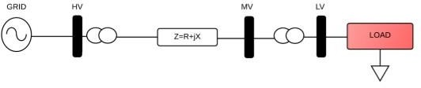

Figure 1: Radial Distribution Network

## **2.2 D-STATCOM Allocation Technique for Loss Reduction**

In essence, the D-STATCOM is a bespoke power device. All that is involved is the use of a STATCOM at the distribution level. A custom power device, the D-STATCOM is connected in series with the power supply and is based on an inverter that measures voltage or current. It is linked to the distribution systems in close proximity to the load. A power VSC that is built on high power electronics technologies is the essential part of the D-STATCOM. A VSC, a group of coupling reactors, and a controller make up the three primary components of the D-STATCOM system. A voltage source converter (VSC) coupled to a direct current capacitor (energy storage device) generates a programmable ac voltage source, which is the fundamental working principle of a D-STATCOM installed in a power system.

D-STATCOM is made up of an inverter, a control unit that produces PWM signals for the inverter switches, a coupling inductance L that is used for current filtering and reactive power exchange between D-STATCOM and the power system, and dc link capacitance C that supplies the inverter with dc voltage. Rdc and Rdc stand for the coupling inductance's winding resistance and switching losses in the inverter, respectively. Reactive power exchange between the distribution system and D-STATCOM is accomplished by controlling the inverter output voltage Vi's amplitude. The phasor graphs in Figure 2 provide an illustration of the D-STATCOM operation.

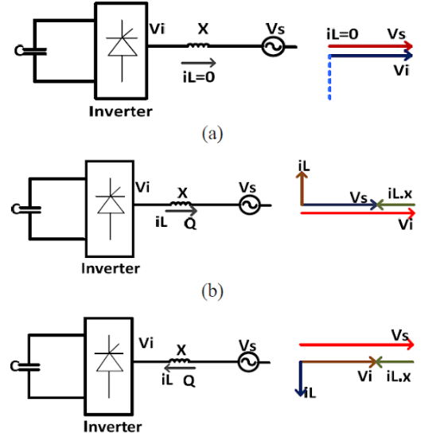

Figure 2:Phasor Graph of D-STATCOM

## **2.3 Power flow/Load Flow:**

The computations of load flow can be solved in a variety of ways. To be deemed acceptable, a load flow approach must meet a number of requirements, such as quick speed, low storage requirements, high dependability, and widely acknowledged simplicity and adaptability, power transmission through the grid system from generators to consumers. Load flow analysis is a crucial precondition for power system research. Regarding the radial feeder for load flow, the backward-forward sweep method is employed.

### **2.3.1 Calculation of load current**

The load current at any bus is given as:

ILn= ……………………..(2.1)

where n =1,2 ….N

ILn= Load Current

N= total. No. of buses Pn = Active power

Qn = Reactive power Vn = Bus Voltage

### **2.3.2 Backward Forward Sweep Method:**

The relation between load current and branch current can be found by using KCL equation. The matrix can Written as:

[IB]= [BIBC] [ILn]…………………..(2.2)

where,

IB= Branch Current

BIBC= Bus injection to Branch Current Matrix

Forward sweep algorithm is used to calculate the voltage at each bus starting from branches from first layer to last layer. Backward Sweep algorithm is used to calculate the branch current starting from the last layer towards the branches connected to root node.

Vn (K)= Vm(K)-IB(K)*Zm(K) ………………(2.3)

Where,

K = 1, 2,…..Nb

Nb= total no. of. Branches= N

Vn (K) = receiving end Voltage Vm (K) = sending end Voltage

The power flow is calculated using backward and forward propagation using iterations. The forward sweep will provide the voltage magnitudes whereas the backward propagation provides the power of each branch. The iterative method has fast convergence as compared to conventional methods. The results for IEEE 33 bus test system are calculated for this Project. It is concluded that the following load flow method is an efficient method for fast convergence tendency in radial distribution networks.

# CHAPTER THREE: METHODOLOGY

This section discusses the methods and case studies used in this project to evaluate the system performance. The power flow along with the optimization technique applied throughout the project are programmed and simulated in MATLAB software.

## **3.1 Collection of Data:**

The process involves choosing an IEEE bus test system that can accurately simulate a low-voltage distribution feeder and reviewing relevant literature to address the issue. For this effort, the IEEE 33 bus test system has been selected. Collection of real feeder data (Substation feeder data, voltage level, resistance and reactance of line, daily monthly and annual loading condition, load and its line configuration) of 11 kV Begnas feeder and finding the low voltage point, nodes and their values at different location from DTR installed, HT metering unit, TOD meter installed in substation and industries.

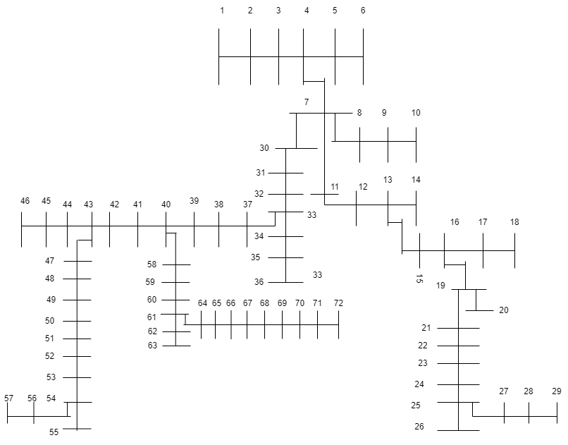

## **3.2 Optimal Location of D-STATCOM**

### **3.2.1 Voltage Stability Index for finding optimal location of D-STATCOM**

Optimal location of D-STATCOM is found by calculating the voltage stability index of all the buses. The VSI is calculated from the following equation:

VSI = ………………(3.1)

Where *Vm* and *Vn* are sending and receiving end voltages respectively; *Im* is the branch current; *Rm* & *Xm* are branch resistance and reactance respectively.

Voltage stability index has been obtained and the bus with highest value of VSI is most unstable and is selected as candidate bus for D-STATCOM. The steps for calculating VSI are described as follows:

Step 1: Read the radial distribution system line data and bus data.

Step 2: Perform the load flow to calculate voltages for all the buses and power losses for all the branches.

Step 3: Calculate VSI for all the buses using equation (3.1).

Step 4: Select the candidate bus with highest value of stability index.

Step 5: Stop.

### **3.2.2 Optimal size calculation by variational technique**

The size of D-STATCOM is calculated using the variational technique. First the base case load flow is made for finding the losses. Then by following steps is used for finding the optimum size of D-STATCOM. Steps for calculating the optimum size of D-STATCOM by variational technique are as follows:

Step 1: Read the line data and bus data and find the candidate bus for D-STATCOM placement by sensitivity method ( VSI ).

Step 2: Place the D-STATCOM at candidate bus with size varying in steps of 50 KVAR

.

Step 3: Find the losses after placement of D-STATCOM.

Step 4: Select the size of D-STATCOM which gives minimum losses.

Step 5: Stop.

## **Flow Chart of Proposed Methodology**

## 

Figure 3:Flowchart of Proposed System

# CHAPTER FOUR: RESULT AND DISCUSSION

## **4.1 Load Flow Analysis of 33 Test Bus System**

Table 1:Voltage Profile and Power loss in 33 Test Bus System

|  |  |  |  |  |
| --- | --- | --- | --- | --- |
| **Bus No** | **Voltage (pu)** | **Branch No** | **Active Power Loss(KW)** | **Reactive Power Loss(KVAR)** |
| 1 | 1 |  | 0 | 0 |
| 2 | 0.997038547 | 1-2 | 12.19332189 | 15.36051758 |
| 3 | 0.982978213 | 2-3 | 51.5711351 | 48.29247661 |
| 4 | 0.975521707 | 3-4 | 19.79340576 | 21.65437072 |
| 5 | 0.968150394 | 4-5 | 18.59307931 | 21.03622619 |
| 6 | 0.949796508 | 5-6 | 38.02565427 | 74.06301088 |
| 7 | 0.94634273 | 6-7 | 1.913078362 | 52.05597305 |
| 8 | 0.941495231 | 7-8 | 4.834177391 | 17.24247674 |
| 9 | 0.935242526 | 8-9 | 4.177332944 | 38.60396591 |
| 10 | 0.929442973 | 9-10 | 3.557541344 | 36.72228607 |
| 11 | 0.928582046 | 10-11 | 0.553073448 | 3.060581379 |
| 12 | 0.927080926 | 11-12 | 0.880221606 | 1.337247846 |
| 13 | 0.920992127 | 12-13 | 2.663757376 | 3.38885528 |
| 14 | 0.918745444 | 13-14 | 0.728555663 | 1.622033486 |
| 15 | 0.917343326 | 14-15 | 0.356856434 | 0.623206166 |
| 16 | 0.915982221 | 15-16 | 0.281320134 | 0.452560561 |
| 17 | 0.913977769 | 16-17 | 0.251482745 | 0.899885446 |
| 18 | 0.913373718 | 17-18 | 0.053102918 | 0.172378172 |
| 19 | 0.996183863 | 2-19 | 0.25926263 | 3.940388191 |
| 20 | 0.992608821 | 19-20 | 0.832707742 | 18.27019756 |
| 21 | 0.991905277 | 20-21 | 0.10082228 | 5.592183727 |
| 22 | 0.991269024 | 21-22 | 0.043662262 | 9.181230293 |
| 23 | 0.979393336 | 3-23 | 3.181201344 | 2.4830946 |
| 24 | 0.97272481 | 23-24 | 5.143202368 | 4.699233982 |
| 25 | 0.969401695 | 24-25 | 1.287331231 | 1.317460163 |
| 26 | 0.947880076 | 6-26 | 2.594008193 | 0.08260666 |
| 27 | 0.945334416 | 26-27 | 3.321056189 | 0.074781348 |
| 28 | 0.933930866 | 27-28 | 11.27662095 | 0.276293464 |
| 29 | 0.925743161 | 28-29 | 7.817989336 | 0.0988582 |
| 30 | 0.92221882 | 29-30 | 3.888125789 | 1.988934441 |
| 31 | 0.918038551 | 30-31 | 1.592823445 | 1.58097857 |
| 32 | 0.917117945 | 31-32 | 0.213084662 | 0.249427438 |
| 33 | 0.916832579 | 32-33 | 0.013161647 | 0.020552165 |
|  |  |  | **201.99** | **134.74** |

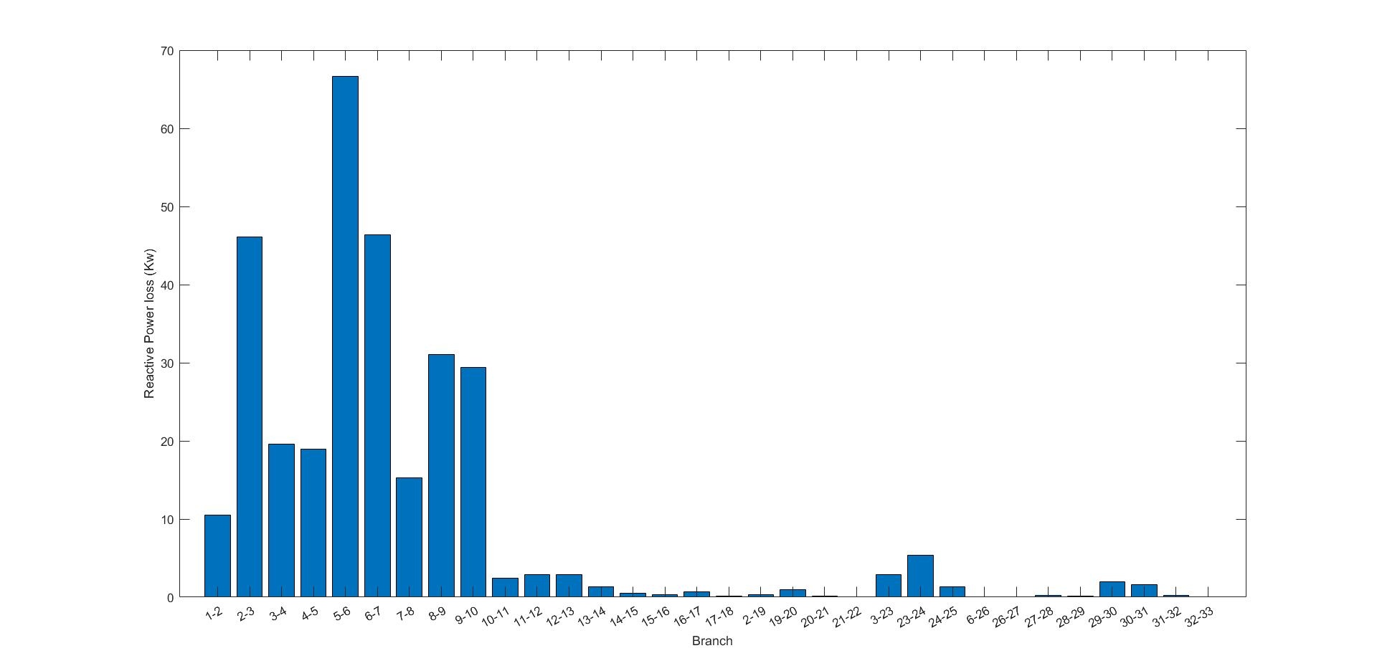 Figure 4:Active Power Loss in 33 Test Bus System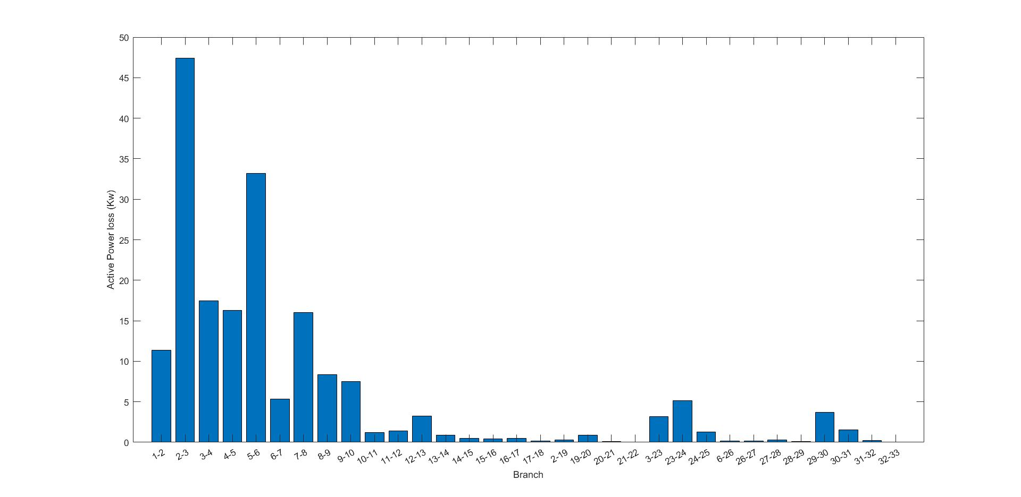 Figure 5:Reactive Power Loss in 33 Test Bus System

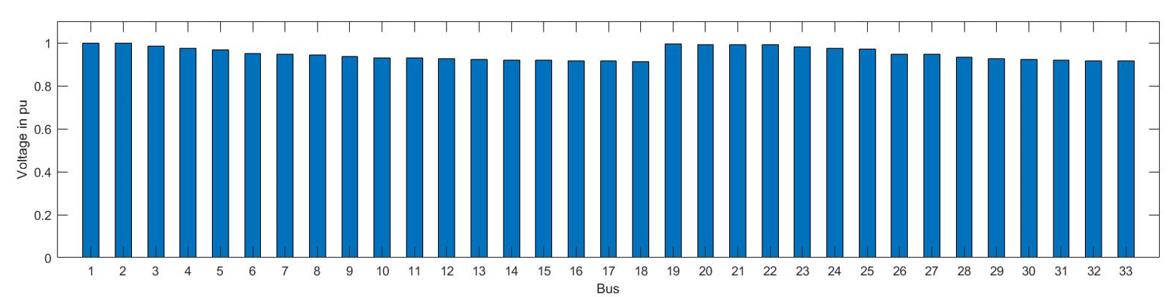Figure 6:Voltage Profile of 33 Test Bus

Backward/Forward sweep algorithm is purposed in testing IEEE 33–bus radial distribution system using MATLAB coding. IEEE 33 bus radial distribution network consists of 33 nodes and 32 branches. The base voltage for this system is 12.66 kV and base MVA is 100. The Total Real power loss is 201.99KW and Total Reactive power loss is 134.74KVAR.The maximum voltage drop occurs in Bus no 18 which is of value 0.9133 pu and becomes 0.9168 pu at Bus no 33.

## **4.2 Load flow Analysis of Begnas Feeder**

Table 2:Voltage Profile and Power loss in Begnas Feeder

|  |  |  |  |  |
| --- | --- | --- | --- | --- |
| **Bus No** | **Voltage (pu)** | **Branch No** | **Active Power Loss(KW)** | **Reactive Power Loss(KVAR)** |
| 1 | 1 | 1 | 0 | 0 |
| 2 | 0.994313148 | 1-2 | 25.98540153 | 29.81931323 |
| 3 | 0.986543414 | 2-3 | 35.12130338 | 40.30313502 |
| 4 | 0.982950887 | 3-4 | 16.16423758 | 18.54912509 |
| 5 | 0.982617885 | 4-5 | 0.035539319 | 0.021849279 |
| 6 | 0.982361875 | 5-6 | 0.018216972 | 0.011199643 |
| 7 | 0.976623293 | 4-7 | 27.15561829 | 31.16218492 |
| 8 | 0.976233884 | 7-8 | 0.121884953 | 0.139867979 |
| 9 | 0.976163065 | 8-9 | 0.013301777 | 0.015264334 |
| 10 | 0.976077885 | 9-10 | 0.005333521 | 0.006120434 |
| 11 | 0.973325205 | 7-11 | 4.31250971 | 2.651295197 |
| 12 | 0.970971121 | 11-12 | 2.739771982 | 1.684389088 |
| 13 | 0.969435339 | 12-13 | 1.676767618 | 1.030862823 |
| 14 | 0.969386135 | 13-14 | 0.003557572 | 0.002187166 |
| 15 | 0.966985927 | 13-15 | 2.497482506 | 1.535431528 |
| 16 | 0.966012486 | 15-16 | 0.851490205 | 0.523489115 |
| 17 | 0.965058247 | 16-17 | 0.138725945 | 0.08528756 |
| 18 | 0.964397768 | 17-18 | 0.048029566 | 0.029528178 |
| 19 | 0.964905768 | 16-19 | 0.706216649 | 0.810412548 |
| 20 | 0.964684293 | 19-20 | 0.008051787 | 0.004950172 |
| 21 | 0.963651534 | 19-21 | 0.681071554 | 0.781557521 |
| 22 | 0.962876956 | 21-22 | 0.371414576 | 0.426213448 |
| 23 | 0.962129183 | 22-23 | 0.382401834 | 0.235097475 |
| 24 | 0.961017212 | 23-24 | 0.32530236 | 0.199993192 |
| 25 | 0.960272808 | 24-25 | 0.163405398 | 0.100460283 |
| 26 | 0.95999463 | 25-26 | 0.010855688 | 0.004108394 |
| 27 | 0.959494598 | 25-27 | 0.121578347 | 0.046011989 |
| 28 | 0.95918261 | 27-28 | 0.036559866 | 0.013836281 |
| 29 | 0.958897404 | 28-29 | 0.011142728 | 0.004217026 |
| 30 | 0.955846744 | 29-30 | 8.710958792 | 9.99618222 |
| 31 | 0.951252375 | 30-31 | 12.84529369 | 14.74050096 |
| 32 | 0.947446504 | 31-32 | 10.41370752 | 11.95015617 |
| 33 | 0.944042486 | 32-33 | 9.106792226 | 10.45041731 |
| 34 | 0.943709067 | 33-34 | 0.06603901 | 0.07578247 |
| 35 | 0.94350606 | 34-35 | 0.020110158 | 0.023077231 |
| 36 | 0.94341839 | 35-36 | 0.002895373 | 0.00332256 |
| 37 | 0.940436875 | 33-37 | 8.948138897 | 10.26835611 |
| 38 | 0.935785205 | 37-38 | 10.94908656 | 12.56452556 |
| 39 | 0.928418329 | 38-39 | 16.89773465 | 19.39084304 |
| 40 | 0.922072188 | 39-40 | 14.39158268 | 16.51493095 |
| 41 | 0.920273036 | 40-41 | 1.893130829 | 2.172445214 |
| 42 | 0.919357118 | 41-42 | 0.90099725 | 1.033931271 |
| 43 | 0.918155344 | 42-43 | 1.141147237 | 1.309513222 |
| 44 | 0.917203796 | 43-44 | 0.09767931 | 0.036967268 |
| 45 | 0.916706085 | 44-45 | 0.030662629 | 0.011604439 |
| 46 | 0.916558504 | 45-46 | 0.003031051 | 0.001147118 |
| 47 | 0.915902638 | 43-47 | 1.944711275 | 2.23163589 |
| 48 | 0.914006525 | 47-48 | 1.572383353 | 1.804374339 |
| 49 | 0.91174654 | 48-49 | 1.79687188 | 2.061984125 |
| 50 | 0.910367051 | 49-50 | 0.611116283 | 0.701280981 |
| 51 | 0.909612124 | 50-51 | 0.174337775 | 0.200059742 |
| 52 | 0.908294913 | 51-52 | 0.246607544 | 0.093329972 |
| 53 | 0.907072223 | 52-53 | 0.178155637 | 0.067423974 |
| 54 | 0.905924804 | 53-54 | 0.119489368 | 0.045221404 |
| 55 | 0.905518884 | 54-55 | 0.016905176 | 0.006397856 |
| 56 | 0.90526275 | 54-56 | 0.04137339 | 0.015657985 |
| 57 | 0.905072053 | 56-57 | 0.003972961 | 0.001503589 |
| 58 | 0.919032137 | 40-58 | 3.711482937 | 4.25907878 |
| 59 | 0.914356977 | 58-59 | 5.993611825 | 3.684822832 |
| 60 | 0.908681704 | 59-60 | 6.393444671 | 3.930636749 |
| 61 | 0.901386576 | 60-61 | 7.937571636 | 4.879953199 |
| 62 | 0.900804347 | 61-62 | 0.04874443 | 0.018447596 |
| 63 | 0.900399541 | 62-63 | 0.016949278 | 0.006414547 |
| 64 | 0.895738511 | 61-64 | 5.252013787 | 3.22889451 |
| 65 | 0.89122954 | 64-65 | 4.105217855 | 2.523853884 |
| 66 | 0.888738105 | 65-66 | 2.068583638 | 1.271748061 |
| 67 | 0.883913519 | 66-67 | 3.812577377 | 2.343940945 |
| 68 | 0.880336771 | 67-68 | 2.536859384 | 1.559640106 |
| 69 | 0.877560601 | 68-69 | 1.856311186 | 1.141244719 |
| 70 | 0.873831146 | 69-70 | 2.41826034 | 1.486726398 |
| 71 | 0.870953993 | 70-71 | 1.628862987 | 1.001411453 |
| 72 | 0.867303993 | 71-72 | 1.916012357 | 1.177948504 |
|  |  |  | **272.5285894** | **280.4847242** |

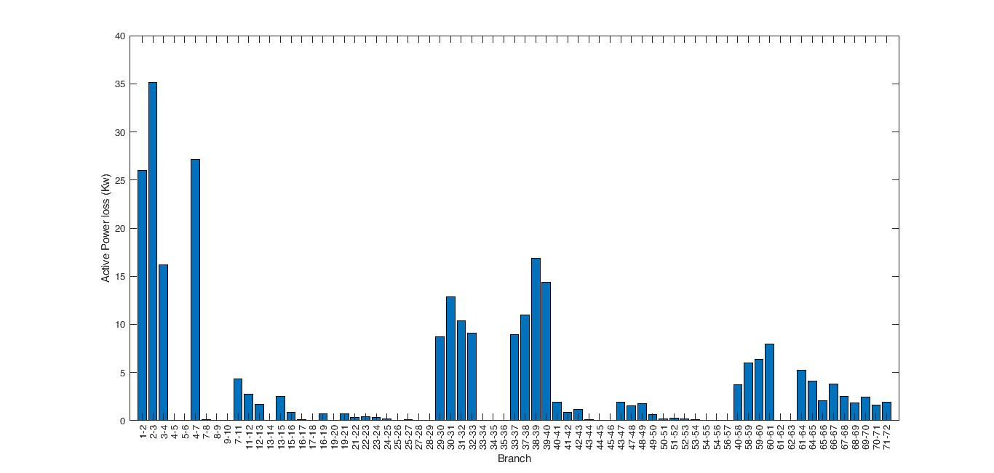Figure 7: Active Power Loss in Begnas Feeder

Figure 8: Reactive Power Loss of Begnas Feeder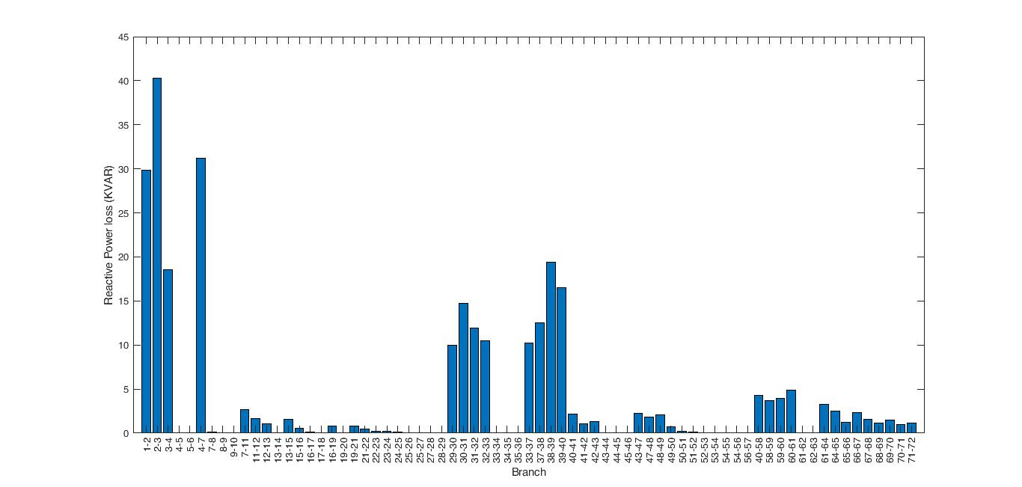

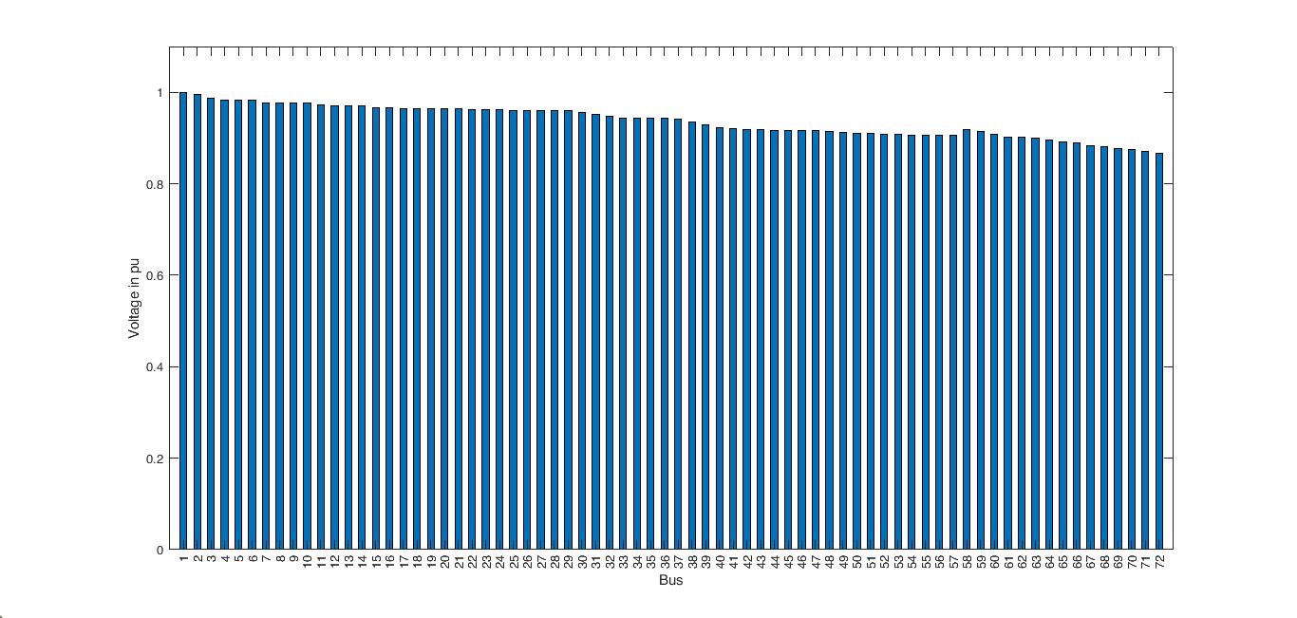

Figure 9 : Voltage Profile of Begnas Feedder

For the load flow in the 11 kv Begnas feeder, The base voltage for this system is 11 kV and base MVA is 100. The Total Real power loss is 272.528 KW and Total Reactive power loss is 280.484 KVAR. The maximum voltage drop occurs in Bus no 72 which is of value 0.8673 pu .

## **4.3 Voltage Stability Index Calculation**

Table 3:VSI of Begnas Feeder

|  |  |  |  |  |  |  |  |
| --- | --- | --- | --- | --- | --- | --- | --- |
| **Bus No** | **VSI** |  | 25 | 6.26E-05 |  | 51 | 6.98E-05 |
| 1 | 1.15E-06 |  | 26 | 2.14E-05 |  | 52 | 0.000119 |
| 2 | 1.56E-06 |  | 27 | 6.53E-06 |  | 53 | 0 |
| 3 | 6.45E-07 |  | 28 | 6.74E-05 |  | 54 | 0.000187 |
| 4 | 6.47E-06 |  | 29 | 8.99E-07 |  | 55 | 0.000241 |
| 5 | 1.99E-05 |  | 30 | 3.33E-06 |  | 56 | 7.76E-05 |
| 6 | 0 |  | 31 | 2.07E-06 |  | 57 | 1.48E-05 |
| 7 | 2.33E-06 |  | 32 | 0 |  | 58 | 5.49E-05 |
| 8 | 6.49E-08 |  | 33 | 5.20E-06 |  | 59 | 3.68E-05 |
| 9 | 1.52E-06 |  | 34 | 6.26E-06 |  | 60 | 0.000177 |
| 10 | 1.41E-05 |  | 35 | 6.81E-06 |  | 61 | 6.85E-05 |
| 11 | 3.66E-06 |  | 36 | 4.95E-06 |  | 62 | 0.000184 |
| 12 | 0 |  | 37 | 6.37E-06 |  | 63 | 3.37E-05 |
| 13 | 1.40E-07 |  | 38 | 1.41E-05 |  | 64 | 7.42E-05 |
| 14 | 1.24E-05 |  | 39 | 0 |  | 65 | 8.37E-06 |
| 15 | 0 |  | 40 | 4.46E-06 |  | 66 | 0.000142 |
| 16 | 0.000127 |  | 41 | 3.64E-07 |  | 67 | 4.07E-05 |
| 17 | 0.000338 |  | 42 | 0 |  | 68 | 1.15E-05 |
| 18 | 3.32E-06 |  | 43 | 0.000155 |  | 69 | 0.000123 |
| 19 | 5.10E-05 |  | 44 | 0.000103 |  | 70 | 4.31E-05 |
| 20 | 7.86E-06 |  | 45 | 3.62E-05 |  | **71** | **0.001403** |
| 21 | 1.35E-06 |  | 46 | 8.17E-06 |  |  |  |
| 22 | 4.27E-06 |  | 47 | 5.55E-06 |  |  |  |
| 23 | 2.51E-05 |  | 48 | 0.000108 |  |  |  |
| 24 | 8.92E-06 |  | 49 | 8.62E-05 |  |  |  |
|  |  |  | 50 | 3.35E-05 |  |  |  |

Voltage stability Index has been obtained and the bus with highest value of VSI is most unstable and is selected as candidate bus for D-STATCOM.It is found that VSI I highest at bus no 71 in our feeder. Hence the optimal location of D-STATCOM placement is Bus 71 by VSI method. Based on VSI approach D-STATCOM is placed for voltage profile improvement and reduction of total power losses. The optimum size of D-STATCOM is found by variational techniques.

## **4.4 Comparison of D-STATCOM size calculation by Variational Technique**

Table 4: Variational Technique for finding the optimum size of D-STATCOM

|  |  |  |  |
| --- | --- | --- | --- |
| **D-STATCOM placed at 71th Bus by VSI method** | | | |
| **Size of D-STATCOM in KVAR** | **Active Power losses in KW** | **Size of D-STATCOM in KVAR** | **Active Power losses in KW** |
| 0 | 272.529 | 1050 | 3514.424 |
| 50 | 268.004 | 1100 | 4005.878 |
| 100 | 260.177 | 1150 | 4535.551 |
| 150 | 251.373 | 1200 | 5103.893 |
| 200 | 244.804 | 1250 | 5711.362 |
| **250** | **244.270** | 1300 | 6358.431 |
| 300 | 253.830 | 1350 | 7045.583 |
| 350 | 277.508 | 1400 | 7773.312 |
| 400 | 319.074 | 1450 | 8542.111 |
| 450 | 381.906 | 1500 | 9352.467 |
| 500 | 468.944 | 1550 | 10204.844 |
| 550 | 582.687 | 1600 | 11099.677 |
| 600 | 725.233 | 1650 | 12037.357 |
| 650 | 898.328 | 1700 | 13018.222 |
| 700 | 1103.419 | 1750 | 14042.545 |
| 750 | 1341.704 | 1800 | 15110.522 |
| 800 | 1614.177 | 1850 | 16222.267 |
| 850 | 1921.666 | 1900 | 17377.804 |
| 900 | 2264.870 | 1950 | 18577.059 |
| 950 | 2644.388 | 2000 | 19819.854 |
| 1000 | 3060.745 |  |  |

From above table it is seen that with the increment in size of D-STATCOM the total power looses in the feeder decreases from that of base power loss i.e 272.529KW.A point is observed where further increase in size of D-STATCOM increases the total active power losses .Thats why the optimum size of D-STATCOM to be used for voltage profile improvement in Begnas feeder is 250KVAR.

# CHAPTER FIVE: CONCLUSION AND RECOMMENDATION

This project focuses on improving the voltage profile of the Begnas Feeder distribution system. The load flow analysis, voltage stability index analysis, and optimization algorithm are the fundamental variational techniques that were employed in this work. The current distribution system's backward and forward load flow analysis is chosen to calculate all necessary parameters. A power flow model for radial distribution networks was created using the Bus Injected to Branch Current matrix (BIBC) approach. The 72-bus 11 kV Bengas Feeder in Lekhnath DC has served as a demonstration of the approach's efficacy and versatility.Hence from VSI we found the most unstable bus is Bus 71 and to improve the stability of feeder the optimum size of D-STATCOM is of size 250KVAR.

Further investigation may focus on the effects of the optimal size and positioning of the reactive power compensator (D-STATCOM) along the distribution network, utilizing alternative optimization algorithms while taking feeder costs and D-STATCOM economics into consideration Installing generating typically has the unintended consequence of raising the grid fault current and negatively affecting other system performance factors, such as protection coordination. Thus, future studies can concentrate on the Distribution systems' protection mechanism.

.

# REFERENCES

[1] Subbarami Reddy1, V Usha Reddy2, "Optimal Placement of D-STATCOM in Radial Distribution System using Fuzzy and Penguins Search Optimization Algorithm," *Innovative research in electrical, electronics, instrumentation and control engineering*, Vols. Vol. 3,, no. Issue 11, pp. 102-106, November 2015.

[2.] Y. T. Gebreyes, "Studies on voltage control of distribution substations using static var compensators," *Addis Ababa institute of technology*, Addis Ababa, 2019.

[3.] T.Taye,"Improvement of Distribution Feeder Loss and Voltage Profile (Case Study:Bella Substation Distribution Feeder)," *Addis Ababa university*, Addis Ababa, Ethiopia, October, 2019“

[4.] S M Suhail Hussain, "An Analytical Approach for Optimal Location of D- STATCOM in Radial Distribution System," *in msubbaramiah, Mahboobnagar*, India., 22 December 2018..

[5]. "Bonyadi, M. R.; Michalewicz, Z. (2017). "Particle swarm optimization for single objective continuous space problems: a review". Evolutionary Computation." (n.d.).

[6]."Optimal placement of DG and DSTATCOM for loss reduction and voltage profile improvement." (n.d.).

[7]."Whale optimization algorithm for optimal sizing of renewable resources for loss reduction in distribution systems." (n.d.).

[8]. "I. Y. Djilani Kobibi, S. Hadjeri, and M. A. Djehaf." *“Study of UPFC Optimal Location Considering Loss Reduction and Improvement of Voltage Stability in Power System* (n.d.). Leonardo Journal of Sciences. Issue.

[9]. Gupta AR, Kumar A (2015) Energy savings using D-STATCOM placement in radial distribution system. Procedia Comput Sci70:558–564.

[10] Gupta, A.R.; Jain, A.; Kumar, A. Optimal D-STATCOM placement in radial distribution system based on power loss index approach. In Proceedings of the 2015 International Conference on Energy, Power and Environment: Towards Sustainable Growth (ICEPE), Shillong, India, 12–13 June 2015; pp. 1–5.

# APPENDIX

Table 5: Specification of ACSR Conductor

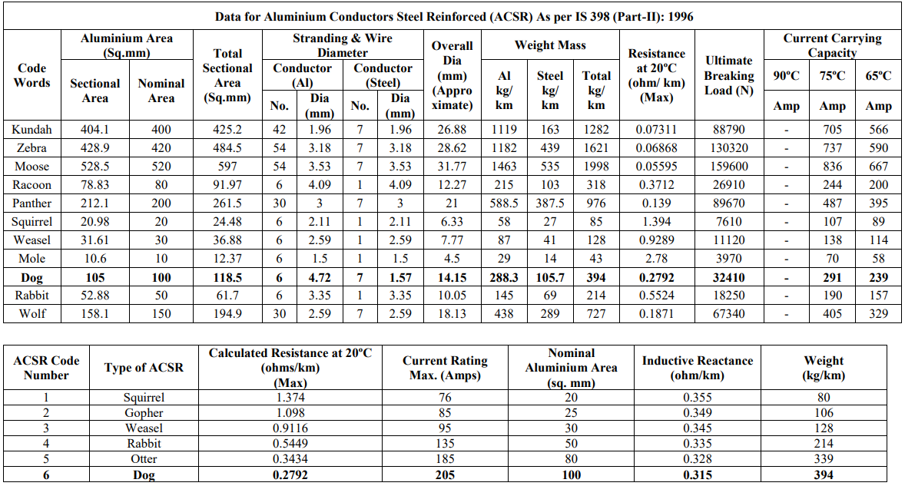

Table 6 : Line Data of 33 Test Bus System

|  |  |  |  |  |
| --- | --- | --- | --- | --- |
| **Branch No** | **From** | **To** | **R (ohm)** | **X (ohm)** |
| 1 | 1 | 2 | 0.0922 | 0.047 |
| 2 | 2 | 3 | 0.493 | 0.2511 |
| 3 | 3 | 4 | 0.366 | 0.1864 |
| 4 | 4 | 5 | 0.3811 | 0.1941 |
| 4 | 5 | 6 | 0.819 | 0.707 |
| 6 | 6 | 7 | 0.1872 | 0.6188 |
| 7 | 7 | 8 | 0.7114 | 0.2351 |
| 8 | 8 | 9 | 1.03 | 0.74 |
| 9 | 9 | 10 | 1.044 | 0.74 |
| 10 | 10 | 11 | 0.1966 | 0.065 |
| 11 | 11 | 12 | 0.3744 | 0.1238 |
| 12 | 12 | 13 | 1.468 | 1.155 |
| 13 | 13 | 14 | 0.5416 | 0.7129 |
| 14 | 14 | 15 | 0.591 | 0.526 |
| 15 | 15 | 16 | 0.7463 | 0.545 |
| 16 | 16 | 17 | 1.289 | 1.721 |
| 17 | 17 | 18 | 0.732 | 0.574 |
| 18 | 2 | 19 | 0.264 | 0.2565 |
| 19 | 19 | 20 | 1.5042 | 1.3554 |
| 20 | 20 | 21 | 0.4095 | 0.4784 |
| 21 | 21 | 22 | 0.7089 | 0.9373 |
| 22 | 3 | 23 | 0.4512 | 0.3083 |
| 23 | 23 | 24 | 0.898 | 0.7091 |
| 24 | 24 | 25 | 0.896 | 0.7011 |
| 25 | 6 | 26 | 0.203 | 0.1034 |
| 26 | 26 | 27 | 0.2842 | 0.1447 |
| 27 | 27 | 28 | 1.059 | 0.9337 |
| 28 | 28 | 29 | 0.8042 | 0.7006 |
| 29 | 29 | 30 | 0.5075 | 0.2585 |
| 30 | 30 | 31 | 0.9744 | 0.963 |
| 31 | 31 | 32 | 0.3105 | 0.3619 |
| 32 | 32 | 33 | 0.341 | 0.5302 |

Table 7:Load Data 33 Test Bus System

|  |  |  |
| --- | --- | --- |
| **Branch No** | **P (KW)** | **Q (KVAR)** |
| 1 | 0 | 0 |
| 2 | 100 | 60 |
| 3 | 90 | 40 |
| 4 | 120 | 80 |
| 4 | 60 | 30 |
| 6 | 60 | 20 |
| 7 | 200 | 100 |
| 8 | 200 | 100 |
| 9 | 60 | 20 |
| 10 | 60 | 20 |
| 11 | 45 | 30 |
| 12 | 60 | 35 |
| 13 | 60 | 35 |
| 14 | 120 | 80 |
| 15 | 60 | 10 |
| 16 | 60 | 20 |
| 17 | 60 | 20 |
| 18 | 90 | 40 |
| 19 | 90 | 40 |
| 20 | 90 | 40 |
| 21 | 90 | 40 |
| 22 | 90 | 40 |
| 23 | 90 | 50 |
| 24 | 420 | 200 |
| 25 | 420 | 200 |
| 26 | 60 | 25 |
| 27 | 60 | 25 |
| 28 | 60 | 20 |
| 29 | 120 | 70 |
| 30 | 200 | 600 |
| 31 | 150 | 70 |
| 32 | 210 | 100 |
| 33 | 60 | 40 |

Table 8: Line Data of Begnas Feeder

|  |  |  |  |  |  |
| --- | --- | --- | --- | --- | --- |
| **Branch Number** | **From Bus** | **To Bus** | **Length(km)** | **R(ohm)** | **X(ohm)** |
|  |  | 1 |  |  |  |
| 1 | 1 | 2 | 0.324 | 0.088938 | 0.10206 |
| 2 | 2 | 3 | 0.45 | 0.123525 | 0.14175 |
| 3 | 3 | 4 | 0.21 | 0.057645 | 0.06615 |
| 4 | 4 | 5 | 0.529 | 0.288252 | 0.177215 |
| 5 | 5 | 6 | 0.61 | 0.332389 | 0.20435 |
| 6 | 4 | 7 | 0.39 | 0.107055 | 0.12285 |
| 7 | 7 | 8 | 0.32 | 0.08784 | 0.1008 |
| 8 | 8 | 9 | 0.097 | 0.026627 | 0.030555 |
| 9 | 9 | 10 | 0.35 | 0.096075 | 0.11025 |
| 10 | 7 | 11 | 0.43 | 0.234307 | 0.14405 |
| 11 | 11 | 12 | 0.345 | 0.187991 | 0.115575 |
| 12 | 12 | 13 | 0.24 | 0.130776 | 0.0804 |
| 13 | 13 | 14 | 0.116 | 0.063208 | 0.03886 |
| 14 | 13 | 15 | 0.41 | 0.223409 | 0.13735 |
| 15 | 15 | 16 | 0.19 | 0.103531 | 0.06365 |
| 16 | 16 | 17 | 1.12 | 0.610288 | 0.3752 |
| 17 | 17 | 18 | 1.55 | 0.844595 | 0.51925 |
| 18 | 16 | 19 | 0.45 | 0.123525 | 0.14175 |
| 19 | 19 | 20 | 1.04 | 0.566696 | 0.3484 |
| 20 | 19 | 21 | 0.6 | 0.1647 | 0.189 |
| 21 | 21 | 22 | 0.42 | 0.11529 | 0.1323 |
| 22 | 22 | 23 | 0.25 | 0.136225 | 0.08375 |
| 23 | 23 | 24 | 0.65 | 0.354185 | 0.21775 |
| 24 | 24 | 25 | 0.58 | 0.316042 | 0.1943 |
| 25 | 25 | 26 | 0.83 | 0.756628 | 0.28635 |
| 26 | 25 | 27 | 0.58 | 0.528728 | 0.2001 |
| 27 | 27 | 28 | 0.31 | 0.282596 | 0.10695 |
| 28 | 28 | 29 | 0.85 | 0.77486 | 0.29325 |
| 29 | 7 | 30 | 0.29 | 0.079605 | 0.09135 |
| 30 | 30 | 31 | 0.448 | 0.122976 | 0.14112 |
| 31 | 31 | 32 | 0.381 | 0.104585 | 0.120015 |
| 32 | 32 | 33 | 0.35 | 0.096075 | 0.11025 |
| 33 | 33 | 34 | 0.45 | 0.123525 | 0.14175 |
| 34 | 34 | 35 | 0.548 | 0.150426 | 0.17262 |
| 35 | 35 | 36 | 0.71 | 0.194895 | 0.22365 |
| 36 | 33 | 37 | 0.402 | 0.110349 | 0.12663 |
| 37 | 37 | 38 | 0.55 | 0.150975 | 0.17325 |
| 38 | 38 | 39 | 0.9 | 0.24705 | 0.2835 |
| 39 | 39 | 40 | 0.79 | 0.216855 | 0.24885 |
| 40 | 40 | 41 | 0.482 | 0.132309 | 0.15183 |
| 41 | 41 | 42 | 0.263 | 0.072194 | 0.082845 |
| 42 | 42 | 43 | 0.358 | 0.098271 | 0.11277 |
| 43 | 43 | 44 | 1.09 | 0.993644 | 0.37605 |
| 44 | 44 | 45 | 0.95 | 0.86602 | 0.32775 |
| 45 | 45 | 46 | 0.845 | 0.770302 | 0.291525 |
| 46 | 43 | 47 | 0.74 | 0.20313 | 0.2331 |
| 47 | 47 | 48 | 0.65 | 0.178425 | 0.20475 |
| 48 | 48 | 49 | 0.81 | 0.222345 | 0.25515 |
| 49 | 49 | 50 | 0.89 | 0.244305 | 0.28035 |
| 50 | 50 | 51 | 0.936 | 0.256932 | 0.29484 |
| 51 | 51 | 52 | 0.83 | 0.756628 | 0.28635 |
| 52 | 52 | 53 | 0.99 | 0.902484 | 0.34155 |
| 53 | 53 | 54 | 1.3 | 1.18508 | 0.4485 |
| 54 | 54 | 55 | 1.15 | 1.04834 | 0.39675 |
| 55 | 54 | 56 | 1.25 | 1.1395 | 0.43125 |
| 56 | 56 | 57 | 1.08 | 0.984528 | 0.3726 |
| 57 | 40 | 58 | 0.71 | 0.194895 | 0.22365 |
| 58 | 58 | 59 | 0.65 | 0.354185 | 0.21775 |
| 59 | 59 | 60 | 0.9 | 0.49041 | 0.3015 |
| 60 | 60 | 61 | 1.2 | 0.65388 | 0.402 |
| 61 | 61 | 62 | 0.82 | 0.747512 | 0.2829 |
| 62 | 62 | 63 | 1.14 | 1.039224 | 0.3933 |
| 63 | 61 | 64 | 1.09 | 0.593941 | 0.36515 |
| 64 | 64 | 65 | 0.89 | 0.484961 | 0.29815 |
| 65 | 65 | 66 | 0.54 | 0.294246 | 0.1809 |
| 66 | 66 | 67 | 1.1 | 0.59939 | 0.3685 |
| 67 | 67 | 68 | 0.91 | 0.495859 | 0.30485 |
| 68 | 68 | 69 | 0.75 | 0.408675 | 0.25125 |
| 69 | 69 | 70 | 1.04 | 0.566696 | 0.3484 |
| 70 | 70 | 71 | 0.92 | 0.501308 | 0.3082 |
| 71 | 71 | 72 | 1.26 | 0.686574 | 0.4221 |

Table 9:Load Data of Begnas Feeder

|  |  |  |  |  |
| --- | --- | --- | --- | --- |
| **Branch Number** | **From Bus** | **To Bus** | **PL (KW)** | **QL(KVAR)** |
|  |  | 1 | 0 | 0 |
| 1 | 1 | 2 | 75.2 | 27.288 |
| 2 | 2 | 3 | 37.6 | 13.644 |
| 3 | 3 | 4 | 150.4 | 54.576 |
| 4 | 4 | 5 | 37.6 | 13.644 |
| 5 | 5 | 6 | 75.2 | 27.288 |
| 6 | 4 | 7 | 0 | 0 |
| 7 | 7 | 8 | 150.4 | 54.576 |
| 8 | 8 | 9 | 150.4 | 54.576 |
| 9 | 9 | 10 | 75.2 | 27.288 |
| 10 | 7 | 11 | 150.4 | 54.576 |
| 11 | 11 | 12 | 75.2 | 27.288 |
| 12 | 12 | 13 | 0 | 0 |
| 13 | 13 | 14 | 75.2 | 27.288 |
| 14 | 13 | 15 | 150.4 | 54.576 |
| 15 | 15 | 16 | 0 | 0 |
| 16 | 16 | 17 | 75.2 | 27.288 |
| 17 | 17 | 18 | 75.2 | 27.288 |
| 18 | 16 | 19 | 75.2 | 27.288 |
| 19 | 19 | 20 | 37.6 | 13.644 |
| 20 | 19 | 21 | 75.2 | 27.288 |
| 21 | 21 | 22 | 37.6 | 13.644 |
| 22 | 22 | 23 | 225.6 | 81.864 |
| 23 | 23 | 24 | 75.2 | 27.288 |
| 24 | 24 | 25 | 37.6 | 13.644 |
| 25 | 25 | 26 | 37.6 | 13.644 |
| 26 | 25 | 27 | 37.6 | 13.644 |
| 27 | 27 | 28 | 75.2 | 27.288 |
| 28 | 28 | 29 | 37.6 | 13.644 |
| 29 | 7 | 30 | 75.2 | 27.288 |
| 30 | 30 | 31 | 75.2 | 27.288 |
| 31 | 31 | 32 | 75.2 | 27.288 |
| 32 | 32 | 33 | 0 | 0 |
| 33 | 33 | 34 | 112.8 | 40.932 |
| 34 | 34 | 35 | 75.2 | 27.288 |
| 35 | 35 | 36 | 37.6 | 13.644 |
| 36 | 33 | 37 | 150.4 | 54.576 |
| 37 | 37 | 38 | 75.2 | 27.288 |
| 38 | 38 | 39 | 37.6 | 13.644 |
| 39 | 39 | 40 | 0 | 0 |
| 40 | 40 | 41 | 75.2 | 27.288 |
| 41 | 41 | 42 | 37.6 | 13.644 |
| 42 | 42 | 43 | 0 | 0 |
| 43 | 43 | 44 | 37.6 | 13.644 |
| 44 | 44 | 45 | 37.6 | 13.644 |
| 45 | 45 | 46 | 18.8 | 6.822 |
| 46 | 43 | 47 | 37.6 | 13.644 |
| 47 | 47 | 48 | 37.6 | 13.644 |
| 48 | 48 | 49 | 376 | 136.44 |
| 49 | 49 | 50 | 225.6 | 81.864 |
| 50 | 50 | 51 | 75.2 | 27.288 |
| 51 | 51 | 52 | 37.6 | 13.644 |
| 52 | 52 | 53 | 37.6 | 13.644 |
| 53 | 53 | 54 | 0 | 0 |
| 54 | 54 | 55 | 37.6 | 13.644 |
| 55 | 54 | 56 | 37.6 | 13.644 |
| 56 | 56 | 57 | 18.8 | 6.822 |
| 57 | 40 | 58 | 75.2 | 27.288 |
| 58 | 58 | 59 | 150.4 | 54.576 |
| 59 | 59 | 60 | 37.6 | 13.644 |
| 60 | 60 | 61 | 75.2 | 27.288 |
| 61 | 61 | 62 | 37.6 | 13.644 |
| 62 | 62 | 63 | 37.6 | 13.644 |
| 63 | 61 | 64 | 18.8 | 6.822 |
| 64 | 64 | 65 | 75.2 | 27.288 |
| 65 | 65 | 66 | 37.6 | 13.644 |
| 66 | 66 | 67 | 75.2 | 27.288 |
| 67 | 67 | 68 | 37.6 | 13.644 |
| 68 | 68 | 69 | 18.8 | 6.822 |
| 69 | 69 | 70 | 75.2 | 27.288 |
| 70 | 70 | 71 | 37.6 | 13.644 |
| 71 | 71 | 72 | 473.76 | 171.9144 |